i-Learning

Constructing a green, sustainable and environmentally friendly campus comprehensively is always the goal since the establishment of school. With the concepts of looking-forward, innovations, and services, the ideas of integrating with the nature, safety, leisure as well as arts and technology is consistent from the overall plans for campus to the establishment of each public facilities and equipment and learning environment. Over the years, there were many excellent results in the perspective of constructing green campus with green energy and low carbon production.

With the efforts of successive principals and actively preparing for funding, energy-saving facilities and equipment were improved and complete campus electricity monitoring and energy-saving management systems were established. After decreasing contract capacity, installing uninstall function on host computers, and conducting control of maximum demands, over 70 million of budget were used in improving the electricity power supply equipment in order to provide perfect and stable power supply environment. We were selected as schools with good energy-saving performance by Ministry of Economic Affair (Bureau of Energy and Water Resources Agency) and Ministry of Education, and our school was awarded with “Excellence Award” of Energy-Saving Good performance, “Energy-Saving & Innovation Award” and “Outstanding Personnel Contribution Award”.

Our school actively uses the idle roof space to cooperate with civil society to promote energy-saving industry. Renting the roof platform to manufacturers to establish photovoltaic system could effectively use the properties of campus and also expanded the capacity to up to 496kWp (Totally generated 2.25 million kWh)

Subsidized by Scholarship of Zhuo-Zhang Zong Education Foundation, the construction and equipment of the sustainable, green, smart and future Vision Gallery, built-in heat exchange system for lake water, sun-chasing system, and energy saving air conditioning, smart lighting and energy monitoring system for collecting solar energy could serve as the displaying platform showing the results of innovations from industry and academics. This could serve as references for industry and academia via the promotion of concepts and techniques of smart energy-saving.

The newly built IER Building has already obtained a Diamond-Level Green Building Candidate Certificate and the certificate for smart building candidate, which made our school become green campus that both consider the concepts of environmental protection and energy-saving. We will continue to promote public construction considering the principles of environmental protection, ecology, education, practicality and economy. Integration the concepts and approaches of green building will help to implement the building design ideas of sustainable development.

To continuously elevate the level of campus intelligence and construct sustainable excellent environment complying with the requirement of environmental ecology, our school has already planned new energy-saving strategies and smart monitoring system in the future to establish campus intelligence and form institutionalized management. Currently, our school actively applied for the “Demonstration Plans for Sustainable Innovation and Implementation of Smart Community” to Ministry of the Interior (Architecture and Building Research Institute) and already obtained subsidy. In the future, our school will integrate in 4 perspectives of energy saving and carbon reduction, safety monitoring, intelligent traffic and health and comfort to comprehensively integrate the functions so as to form smart management and provide a comfortable, energy-saving, convenient and safe environment.

Environmental and Safety Technology Center is responsible for the processing of sewage in campus to provide reclaimed water for irrigation of flowers and plants in campus and the toilet flushing in student dormitory to save water. Also, rainwater is also recycled and reused with certain measures. As for the waste liquid and medicals produced by laboratory, centralized management is the corresponding approach to solve the related problems. In laboratory and practice places, labeling hazards, determining processing environment, management of dangerous mechanics and equipment as well as the planning, promotion, investigation, suggestion, and supervision stipulated in regulation are implemented to continuously maintain the goal for zero disaster in practice places.

Smart Campus

Establishment of friendly campus environment is also one of school’s goals. Student dormitory was built in campus. As time passed by, some of the traces were also left in dormitory. Hence, in addition to the continuous improvement in the accessible accommodation space, certain budget is used in the repairs and modification of dormitory every year. There were construction project that break the original design pattern in the right side of A1 dormitory building to replant into suite pattern in order to provide boarders with higher accommodation quality. There are independent bathroom amenities, sinks, and air conditioning in each bedroom. This undoubtedly provides boarders with more comfortable environment and also solves the worries and inconveniences of boarders.

1. Good at controlling electricity usage

Since the establishment of our school, we actively promote lots of measures to control and save the usage of electricity. As the development of technology, information and communication technology was introduced into the applications of building energy-saving management. In addition to largely elevating the effects of saving energy, the security and comfort of school life could also be confirmed. Therefore, green building design and systematic smart monitoring management are gradually integrated. Take advantage of well-conducted monitoring system to control and supervise the current uses of electricity and coordinate the demands in both peak time and off-peak time to effectively transfer the electricity usage in peak time to elevate the load rate and lower the costs. Campus electricity monitoring and energy-saving management system was established in 2008. In 2014, the system was expanded and improved to strengthen the functions to record the energy usage of each substation in detail; Information collected from each substation provided immediate electricity usage data for further analyses and comparison. Collocation with reasonable demanding amount could decrease the over-usage penalty fees and energy charge. For example, the capacity of original electricity contract is 5,300 kW. If the optimal capacity is 4,488 kW after analyzing the electricity usage in recent years, the loads will be preserved to increase the elasticity. Since November, 2014, the electricity usage was lowered to4, 600 kW. The uninstall function of central air conditioning host computers in library, administration building and auditorium were installed to conduct maximum demanding amount control to both consider the control and comfort of using electricity.

2. Elevate efficacy with energy saving equipment

In order to promote sustainable green campus and energy saving and carbon reduction, in addition to the existing environment policies and energy-saving goals in campus, the overall plan and update of facilities and equipment has already laid foundations for the talent education and research and development in green industry; energy audit system also has been implemented. The design of green building was integrated into new construction to elevate or replace existing air conditioning, energy-saving lighting equipment and establish electricity monitoring system; and simultaneously plant the seeds of energy-saving into students’ and faculty’s mind via environmental education in daily life. The main item to elevate the performance of using facilities and equipment is listed below.
- Establishment of Solar Water Heating System and information center in Student Dormitory A1, A2 and A3.
- Establishment of heat pump hot water system, 186 T5 high efficiency energy saving lamps and information center in Student Dormitory F.
- Establishment of heat pump hot water system in Student Dormitory G.
- Establishment of 610 T5 high efficiency energy saving lamps and information center in administration building.
- Replace old and energy-consuming mercury street lamps with complex metal street lamps.
- Applying card management approach to control the electricity usage of air conditioners in student dormitory.
- Improve energy-saving of high-voltage electricity and renew construction projects.
- Replace with high-efficiency water chillers.
- Access control of classroom space and electricity management system.
- Activate waterway of reclaimed water to restore detention and storage functions.
- Install automatic lighting with sensors in library.
- Replace the exit lights and indicator lights for evacuation routes with LED products.
- Independently research and develop clean energy car and replace old service cars.
- Install timing control in drinking fountains in campus.
- Upgrade the lamps in library and stadium to T5 high efficiency energy saving lamps.
- Add external shading in the elevation of southern Engineering Building 3.
- Lease roof-type solar power generation system
- Build a sustainable, green and smart Vision Gallery
- Do the pumping works in the night in water tower in Engineering building 3
- Improve electricity monitoring system and load management
- Replace two-stage electricity tariffs with three stage electricity tariffs (save about 2 million dollars every year)
- The capacity of electricity contract was lowered from 5,300kW to 4,600kW.
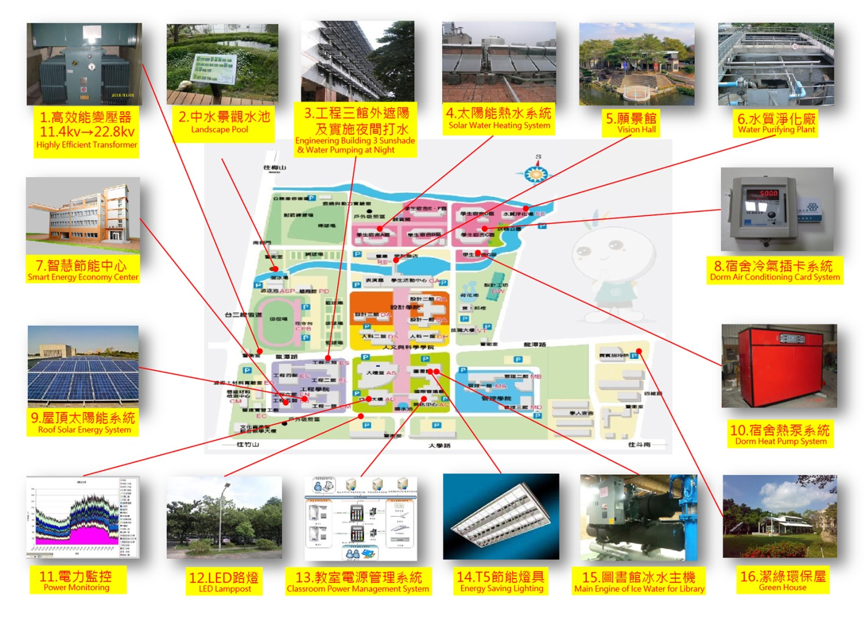

3. Change voltage with substation to make the provision of electricity smarter

Our school was established so far and many of the original high-voltage electricity equipment (ex. Transformers, high-voltage switch, high-voltage cables, high-voltage capacitors and protective relays) has already reached the life time limits. This not only caused larger energy consumption but also influenced the stability of power supply. As more departments and colleges were increased, electricity equipment and devices were procured and the actual electricity usage situations were also adapted. Also, owing to the requirements for high-voltage electricity users stipulated by Taiwan Power Company, the power supply was changed from 11.4kV to 22.8kV, which would cooperate with demands to alter the voltages while supplying electricity to ensure the complete and stable power supply environment.

To stabilize power supply quality and implement the energy-saving ideas to save electricity, our school actively prepares funding for improvement. About 70 million dollars were budgeted to promote the electricity voltage-altering operation in campus and high-efficiency electric equipment for high-voltage electricity would be simultaneously applied in higher priority to decrease the loss of power wires, copper loss of main transformer, and copper and iron loss of transformer in buildings so as to save electricity consumption and reduce CO₂ emissions to reach the effect of energy saving and carbon reduction.

Currently, our school has completed the related operations for the voltage-alteration of high-voltage equipment in northern campus. Also, the transformers of high voltage cubicles in Design Building 2 were updated from 750kVA to 500kVA and were connected via second time side TIE. Design Building 1 used two of the existing 750kVA transformers and connected via second time side TIE to lower the iron loss, which saved about 49.337 kWp of electricity and about 162.8 thousand NTDs every year. In south campus, Building1, 2 and3 of College of Design, College of Humanities and the voltage-altering works in Humanities Building were continuously completed to fully maximize the energy-saving efficiency and ensure electrical safety.

In addition to actively renew and improve energy-saving equipment in campus, electricity monitoring and energy-saving management system were also established to record the data of electricity uses in each substation in detail to allow the analyses and control of electricity uses. Analyzed data and information could serve as reference to determine whether the contract capacity should be lowered. Installation of air conditioning uninstallation function in monitoring system could facilitate the highest demanding amount supervision in different stages. When the load demands exceed certain set values (ex. 4,300kW or 4,600kW), the air conditioning of library, Administration Building, and Auditorium will be switched off (uninstallation) orderly in different stages.

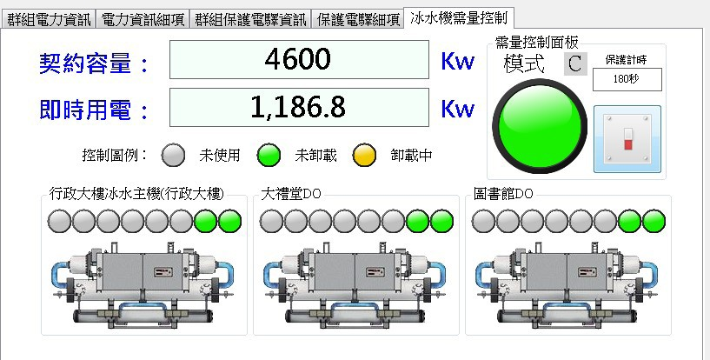
空調冰水主機需量控制

4. Sustainable, green, smart and innovative future Vision Gallery
To provide a place to exhibit the innovations energy-saving lectures and energy saving results, our school self-raised funds and adding 15 millions of donation from Scholarship of Zhuo-Zhang Zong Education Foundation to invest 30 million dollars to build a sustainable, green and smart Vision Gallery next to Yun Meng Lake, which utilizes the functions of the lake and pools to design waterfront ecology, rainwater recovery, heat exchange system of lake and ground water, photovoltaic system, sun-chasing system, energy saving air conditioning, and energy monitoring system , etc. to serve as the displaying platform for innovations of industry and academia. Cross-domain green low-carbon technology and innovations were also integrated in the implementations of green energy, smart energy-saving and the researches, development, and lecturing of smart green building to cultivate talents for green smart innovations. Besides, YunTech serves as fields to practice and experience cross-domain “Green Tech Program” and” Energy & Electricity Saving Program”, and shows the results of innovations from industry and academics. This could serve as references for industry and academia via the promotion of concepts and techniques of smart energy-saving.

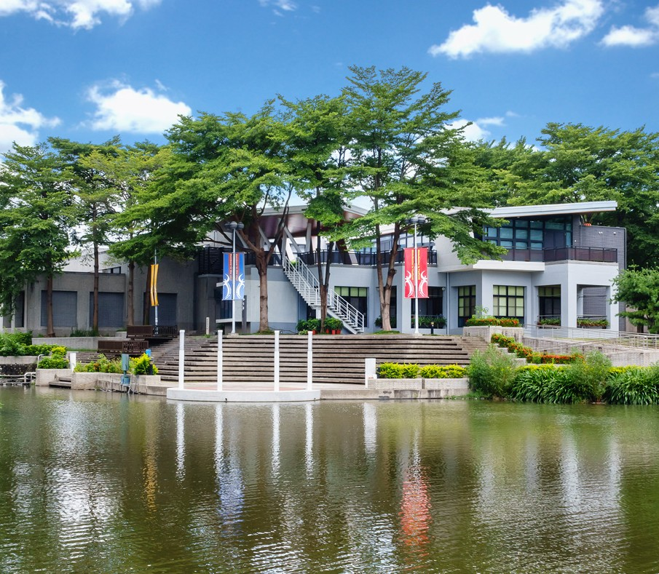 | 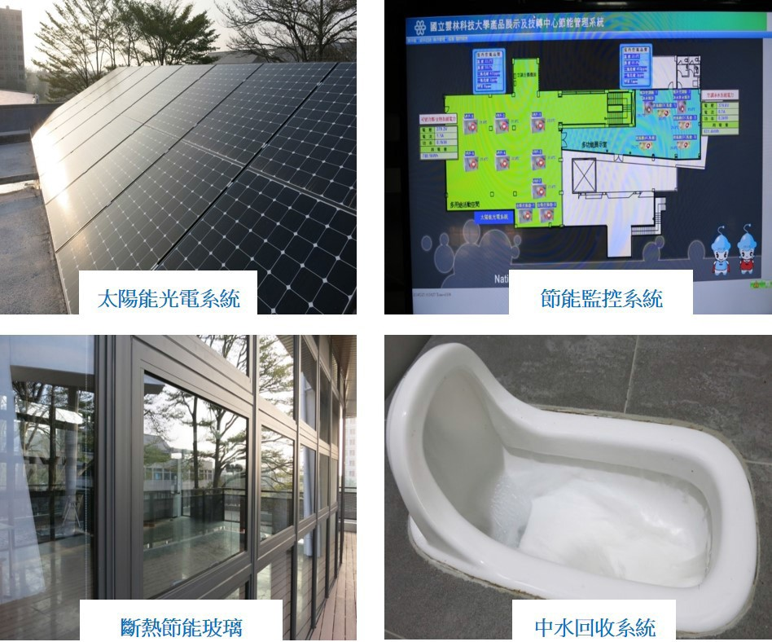
願景館周邊整體環境場景 | 願景館節能設計

5. Good energy saving efficacy allows the sustainable environment become possible

a. In response to the teaching demands, new schoolhouses were continuously built and the floor areas also gradually increased year by year. In cooperation with Executive Yuan to implement “Comprehensive Energy Saving and Carbon Reduction Measures for Government Agencies and Schools” and “Four Saving Items (saving electricity, saving oil, saving water, and saving papers) Projects for Government Agencies and Schools”, the electricity using amount of our school has always showed negative growth since 2007 and was much better than the requirements in Four Saving Items Project. Furthermore, the average electricity usage of each person every year as well as the electricity usage per unit floor areas also showed decreasing trends.

b. Sewage treatment plant, which recycled water to reuse in watering, landscaping, and firefighting, was built in the early establishment of our campus. The water reuse rate is about 60% to 70%. This not only help the greening and landscaping of campus but also effectively save the usage of running water. Our campus thus could be regarded as the model school showing the results of saving water and energy as well as reducing carbon production. Moreover, the average electricity usage per person every year and the electricity usage per unit floor areas also showed decreasing trends yearly.

Environmental Ecology

1. The floor areas of schoolhouses

In 2012, after the construction of Engineering Building 6 was completed, construction of Technical and Vocational Building, Management Building 1, Vision Gallery, Language Center and IDF YunTech also increased floor areas up to 2307.21 square meters in total to expand teaching spaces and improve the functions of old schoolhouses. Now the total areas for schoolhouses are 269,868 square meters.

2. Diamond-level green building developed via industry-university cooperation

To develop the mission for model university of science and technology project to strengthen the connections between industry and academics via infrastructure and to fully cater to the demands of industrial and commercial development as well as talent needs in both domestic and foreign industry, our school built IER Building with both the funds from Ministry of Education and self-raised funds. The total budget for the construction of I YunTech RR Building is 418.561 million NTDs and the scale for the building includes 1 underground floor and 8 floors on ground with totally13, 846 square meters. There will be achievements exhibition space, multifunction practice factory, technical information and innovative center, industry association, incubation center for academia-industry collaboration and intellectual property, factory incubation room, student micro-enterprise incubation room, trial-production center for R&D outcomes, product testing center, specific production line simulation facilities, technology school innovation and entrepreneurship platform in central region in the internal space to serve as YunTech’s windows of academics to the industry for application researches and connections with the industry.

To continuously promote green campus with the ideas of environmental protection and energy-saving, YunTech IER Building could serve as fields to practice and experience cross-domain “Green Tech Program” and” Clean green sustainable science and technology Program”. YunTech has already obtained a Diamond-Level Green Building Candidate Certificate and displayed the innovative results and promoting the best model. The indications include 9 indexes:
Biological diversity (plan ecological jungle to increase biological habitats), Greenery (use ecological coating methods to plant new plants in order to reach biological diversity), Daily Energy-Saving (use energy-saving materials and equipment in the walls, air conditioning, and lighting system of the building), Indoor Environment (use green building materials to lower the damage levels of the Earth), Water Resource (use water-saving equipment and rain reclaimed water facilities), Sewage and Garbage Improvement (set green landscaping garbage and resource recovery concentration field), Rainwater Conservation (increase permeable green lands and pavement), Waste Reduction (use recycling building materials and reduces waste) and CO₂ Reduction (use recycling building materials and reduces waste).
Also, the building has already obtained the certificate for smart building candidate, which includes safety and disaster prevention (firefighting safety equipment system and smart access control security management integration system), health and convenience (uniformity adjustment facilities for the illumination of each room), sustainable energy saving (with high-efficiency equipment or equipment complying with national energy-saving badges such as T5 lights, pumps, air conditioning host computer, water saving equipment, etc.). Through introducing smart high-technology techniques and applications of materials and products, buildings could become safer and more convenient and comfortable. By doing so, our school could become green campus emphasizing environmental protection, energy saving, and ecology.
3. Recycles of reclaimed water to protect the environment

The reclaimed water utilization system in campus is to process the urban sewage to reach certain water quality standards and use the reclaimed water repeatedly in non-drinking water and water without contacts with human bodies. The main use of reclaimed water is for flushing in toilet, garden irrigation, road moisturizing, car washing, fountains, water used in promenade facilities, and water for cooling down equipment. There is also billboard hanging above faucets for watering. (Saying that the secondary waterway providing reclaimed water for watering flowers only and cannot be used as water to drink or washing hands)

In the early stage of establishment, school already planned sewage collection pipeline system and set a sewage treatment to process the sewage produced by students and faculty in daily lives with biological extension aeration method. The sewage is firstly processed with secondary extension aeration method and part of the processed sewage is further proceeded thirdly. Then the processed water will be recycled to groundwater water supply system to replace the original groundwater to serve as the water used in landscaping, firefighting, artificial lakes, and flushing of toilets in student dormitories. The recycle rate of sewage is about 60% to 70% every year.

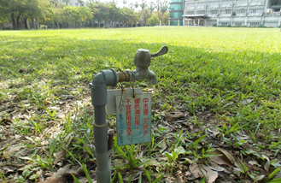
中水澆花用水龍頭
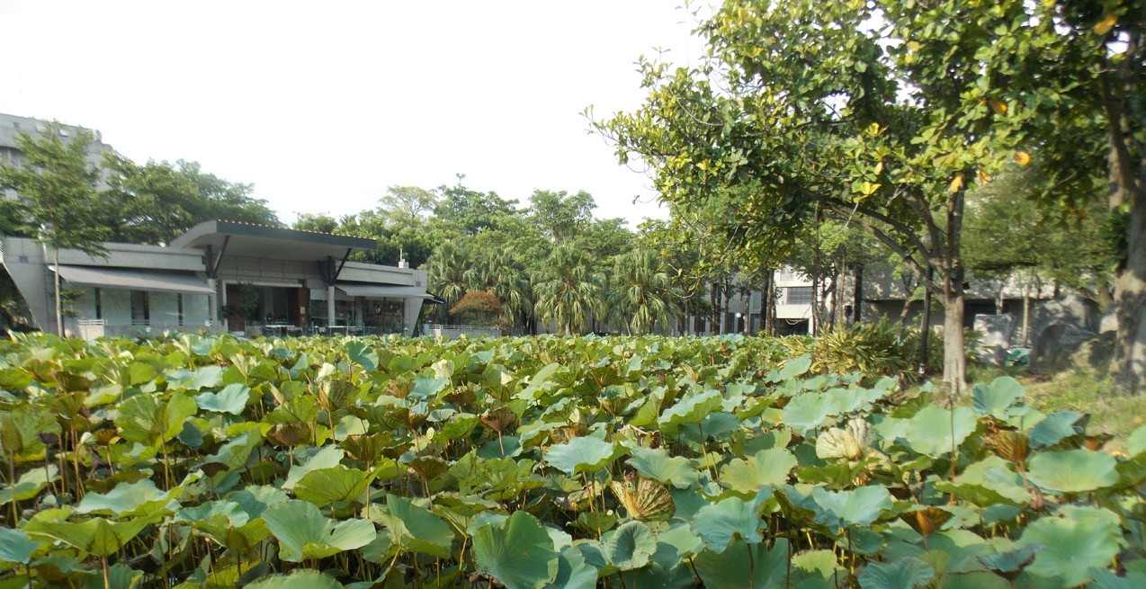
人工湖補注
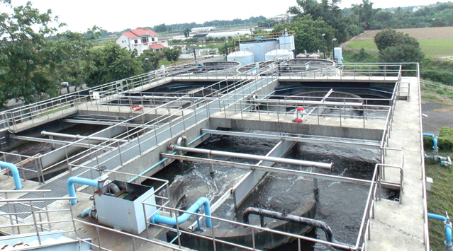
污水處理場

Green YunTech

1. Establish solar energy system on roofs
In response to the government’s Renewable Energy Program to establish green energy-saving and low carbon production environment, in addition to promoting an exemplary university of low carbon and making an energy-saving management plan, our school utilized idle roof space since 2012. With the application of private resources and capitals and equipment provided by manufacturers, roof-type solar power generation system (495.88kWp) was installed on the roofs of Engineering Building 1, 4, Administration Building, Information Center, International Conference Hall and Auditorium.

Roof-type solar power generation system can effectively isolate the heat energy from the roof and effectively reduce the indoor temperature to decrease the electricity consumption. Renting the idle space on top floor can effectively activate school assets and earn about 700,000 NTDs for school funds every year. Also, teaching and research equipment for photovoltaic system with values near 100 million NTDs was added to intensify the cultivation of talents, research and development of green industry, innovations, exhibition, and promotion. This arouses the environmental awareness of students, faculty, and neighbors in neighboring communities, which shows positive demonstration and functions in green environmental protection education.

Energy Saving Effect: The totally estimated output values of the 20-year project is about 46 million NTDs and it is estimated to generate 12,000,000 kWp electricity, which can be regarded as reducing 6522 metric tons of carbon production, equivalent to the carbon dioxide consumed by 530,000 trees for 20 years.

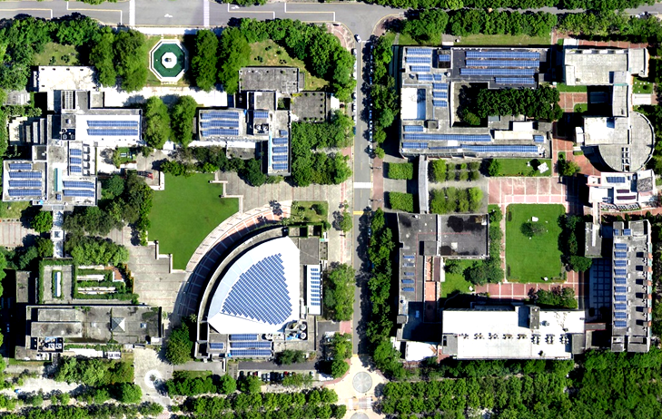
太陽能光電屋頂裝置實況-空照圖
2. Establish green campus-campus landscape

The school place for our campus is about 58 hectares. The overall plan for the campus is consummate and there is always blooming flowers and green grass in every season to provide students and faculty with beautiful learning environment. In addition to emphasize both the software and hardware construction in campus planning to support teaching, researches, learning, the environmental education functions are more important. Promotion of the artistic and green landscaping works in campus and sparing no efforts in the maintenance of ecology in campus by Office of General Affairs and all the students and faculty in school could actively create excellent and beautiful learning environment to develop the beauty of campus landscaping together.
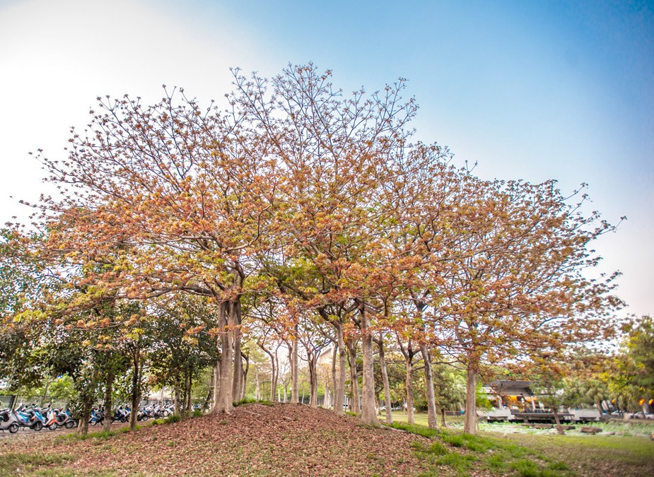 | 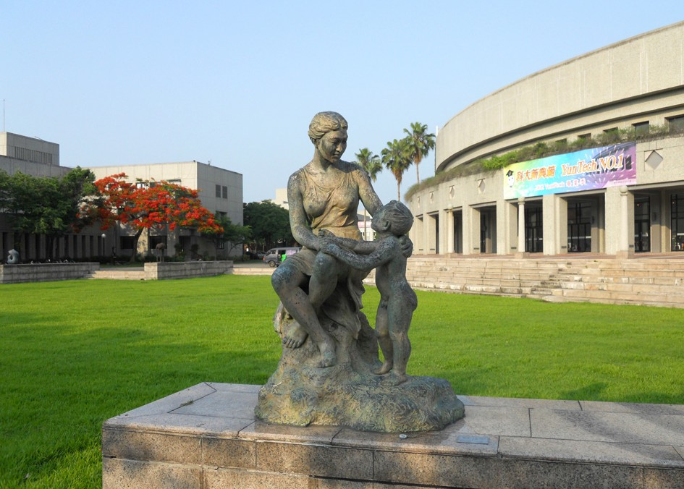
優美校園工坊旁 | 人文殿堂 - 親情
Our school carefully maintains the quality of campus by introducing art center with art works in the outdoor public spaces and spaces inside the buildings to shape the characteristics of campus landscape. Sculptures could shape the space beauty in the green and vast campus and students, faculty, and visitors could appreciate the beauty of sculptures as a form to get close to arts. This not only provides opportunities for environmental education but also bring arts into the campus to reach the goal of creating artistic atmospheres in campus. Students and faculty have the accesses to appreciate and get close to arts and even can contacts with arts. This became parts of lives and can elevate the artistic and cultural levels to reach the realm of “making arts become your life and making your life artistic”. Plenty of trees and flowers in campus not only provide students, faculty, and personnel with best living environments but also attract neighboring residents to exercise and recreate in our campus. Many classic backgrounds in wedding photography are also from our campus. This cultivates the temperaments of both students and faculty and broadens their minds. Moreover, this also shows quite efficiencies in the perspective of attracting residents in neighboring communities to join in.

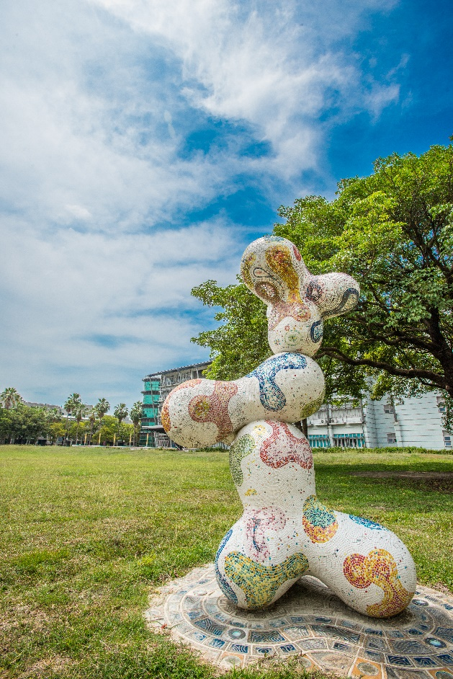 | 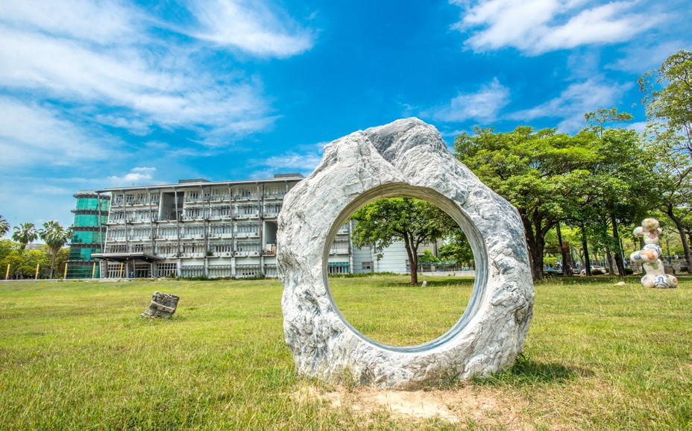
校園藝術品 - 設計 DNA | 校園藝術品 - 太初

3. 9 landscapes of YunTech

To manage the green campus and community education environment and extend campus education to the exterior zones and inspire both the students and faculty in mind level, the 9 landscapes are created in the main entrance, bell tower, big turf, lotus pond, Yun Meng Lake, Rotary Park, YunTech Cloud Tower, Longtan Green tunnel and Time capsule area. Via the introduction of environment in every attraction and image shaping, students could learn in cheerful environment. Through the combination with community activities, campus education could thus expand. The green construction results are shared by students, faculty, and community. Every student or visitor can be inspired or touched in mental level from environments in campus to reach the environmental education goals.

- ”Vivification”- Image creation area on the main entrance
To shape the images for landscapes in campus, the scene you would see after entering the main entrance are pool fountain with eight diagrams in traditional Chinese Culture covering Taiji. These public works of art symbolize the continuously changing Taiji. The continuation of vision is Central Square with axis trail to enter Activity Center. There are gigs lawns in the both sides of the main entrance, which symbolize the open mind of our school.
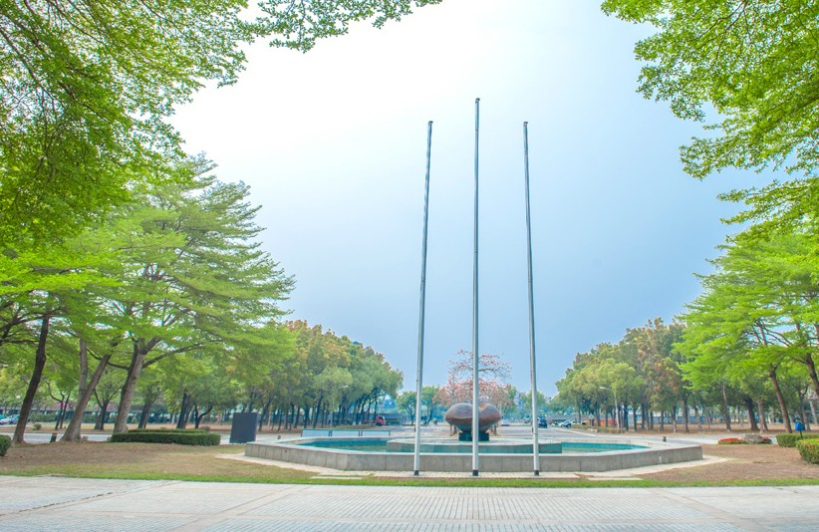
雲湧八方Vivification - 八卦水池
- ”Spirit of YunTech”- Music regions in bell tower
The Learning Center combines the architecture features of Romanesque Auditorium and overhanging plants of library. The Bell Tower becomes the spiritual fortress symbol of YunTech in campus since students’ activities including weekly meetings, school anniversary, social activities, and graduation ceremonies are all held here. There are stone tables and chairs as well as leisure art tables and chairs around and under the trees to extend the browsing and discussion spaces from library to outdoor. Listening to the music from the Bell Tower, and the sounds of water near International Conference Hall and Library. with the accompany of bell rings, we continue our daily learning lives by lighting the torch of school sports competition, throwing celebrations and fairs, school anniversary, and taking photos in graduation ceremonies. Here is the where we share our memories. Here is our spiritual benchmark.

- “Green art prairie” - Big turf art teaching region
Big turf, combining the planning ideas of teachers in Department of Space Design to create the extending visual feelings and letting the teaching spaces broaden to corridor, atrium, and turf instead of limited to only classroom, is one of the main characteristics of our campus landscaping. This could let students experience learning in different spaces.

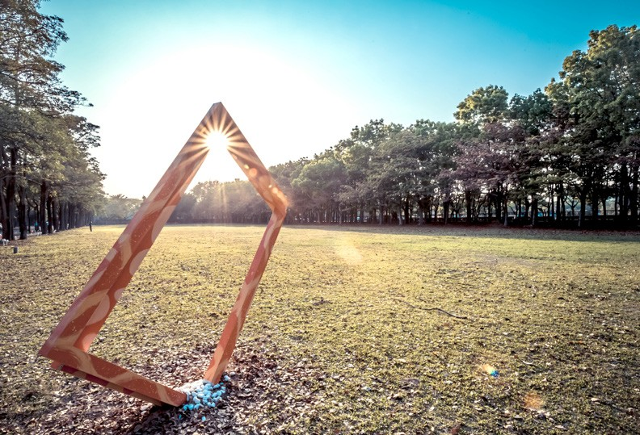 | 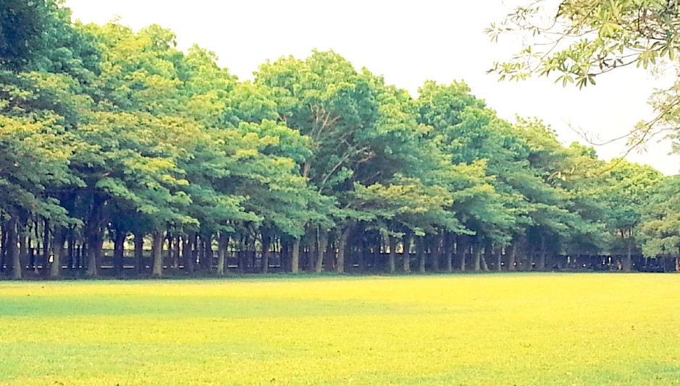
青青大草原 - 悠雲大道藝術品 | 青青藝術大草原

- Lotus Pond of The Clouds-Aquatic plants in lotus pond Recreation areas with landscape
Blooming lotuses of YunTechin Lotus Ponds will amaze you. When it comes to mid-May, the blooming seasons for lotus, there will be lotus sketch competition by the poolside of Lotus Pond held buy Art Center. Musicians and people from neighboring communities will be invited to participate in this spiritual art festival.
Taste coffee and admire the beauty of lotus in “The Clouds”. There are little bridge and stones to connect to the island in the middle of pond. There are trees and flowing water on the island, where the white geese resting in. There is another ecological area in the forest zones next to the pond. The coffee house behind the glass wall is the place for residents, students, and teachers to chat and talk.

- “Yun Meng Lake” -Ecological Scenic Area
There was no name for the lake in the early stage of establishing campus. The lake, originally called artificial lake, was formed by the ditches while widening for irrigation. Members of graduate student association thought it was a pity that there was no name for the lake and initiated name recruitment for the lake in 1999. “Yun Meng Lake” was selected as the name for the lake since the name inspires alumni to chase their dreams and ideals. Crystal pool water makes viewers to wander with relaxed and happy moods. There are ducks, geese, and fish swimming in the “Yun Meng Lake”. Lantana camara blooms along with lake trail. Professional faculty and teachers in both Department of Space Design and Department of Construction planned to flow the purified reclaimed water in the lakes with waterways to restore natural ecology.

Vision Gallery : To provide a place to exhibit the innovations energy-saving lectures and energy saving results, our school self-raised funds and adding 15 millions of donation from Scholarship of Zhuo-Zhang Zong Education Foundation to invest 30 million dollars to build sustainable, green and smart Vision Gallery next to Yun Meng Lake, which utilizes the functions of the lake and pools to design waterfront ecology, rainwater recovery, heat exchange system of lake and ground water, photovoltaic system, sun-chasing system, energy saving air conditioning, and energy monitoring system and etc. to serve as the displaying platform for innovations of industry and academia.

- “Rotary Park”- Ecological Water Purification Area
Flowing water under bridge with bending roads seems to welcome the returns of students. Rotary Park, featured with both natural landscapes and southeast style, contains trails alongside the hills with sleepers between student dormitory regions and parking lots for motorcycles. Water purification works are conducted in the downstream of river connecting to Yun Meng Lake and here also formed a natural ecological region. In this region, the endless vitalities of Nature could be observed from the mutually dependent food chains, where is also a substantial natural education place.

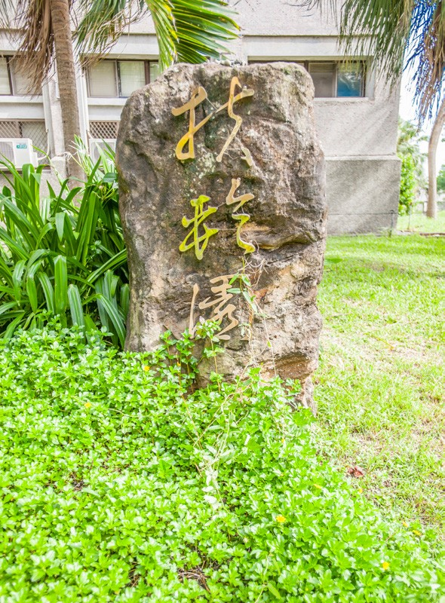 | 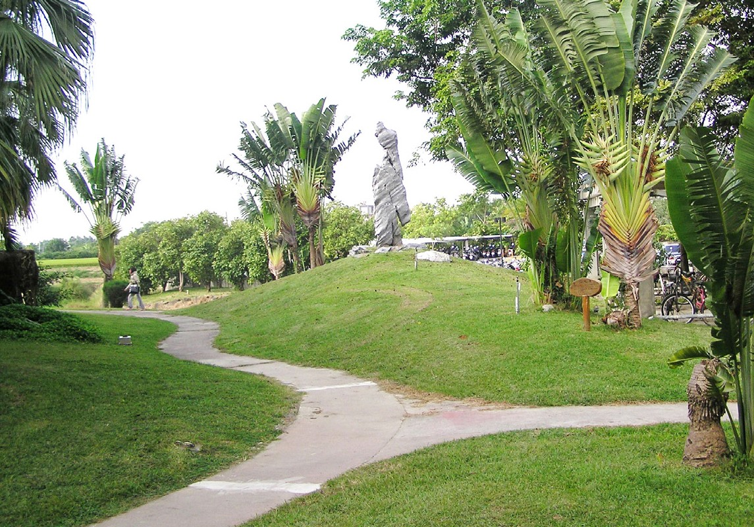
扶輪園 | 水質淨化生態區 - 步道
- YunTech Cloud Tower - Multilevel ecology green regions
YunTech Cloud Tower, the landmark of the campus - 50 meter high and the viewing platform to overlook the urban areas and beautiful scenes with broaden visions. The surrounding grasslands, trials alongside rivers, and big square are good choices for students to spend their leisure time. The neighboring baseball field in forest areas is planned as the natural ecological forest areas for birds and insects and the Black bottom ditches areas for aquatic creatures. Students and residents in communities could further understand knowledge about natural ecology with recreational moods.
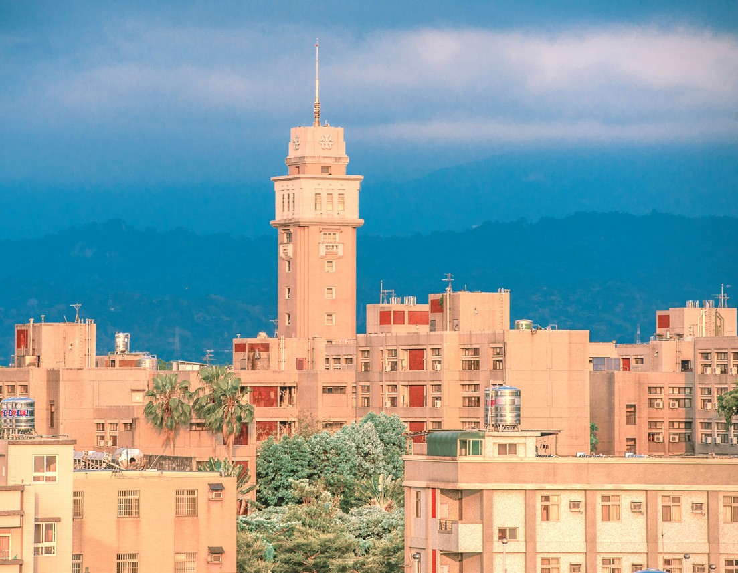 | 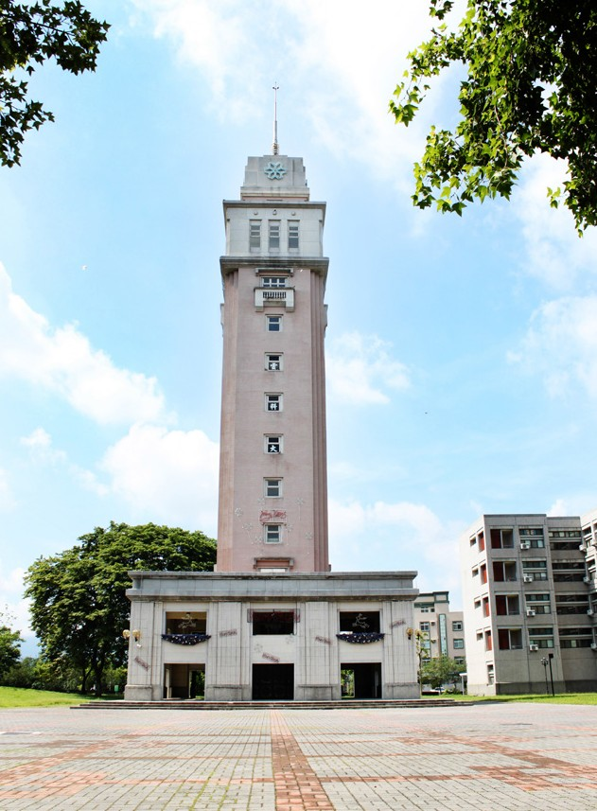
觀雲閣 | 觀雲閣-大廣場
- Longtan Plaza-Green art district
Our school cooperated with the old street rebuilding program of Douliu City Office to modify the both sides of Longtan Rd. into artistic and humanities recreation center. The roads were broadening and parking shed as well as sleepers for flower beds were added. Big events could be held on Longtan Rd. after modification. The broaden roads also allow students and faculty to exhibit their works and could serve as activity spaces for throw up various arts activities. Longtan Recreation Square has become a green corridor for students, faculty, and people living nearby to participate in folklore, arts, and leisure activities, which promote the win-win strategy in the resource-sharing between school and communities.

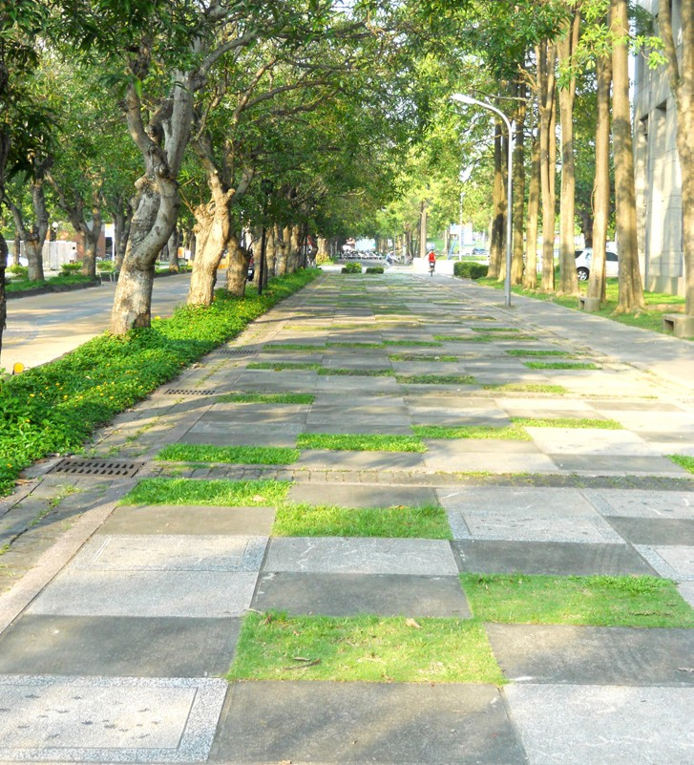 | 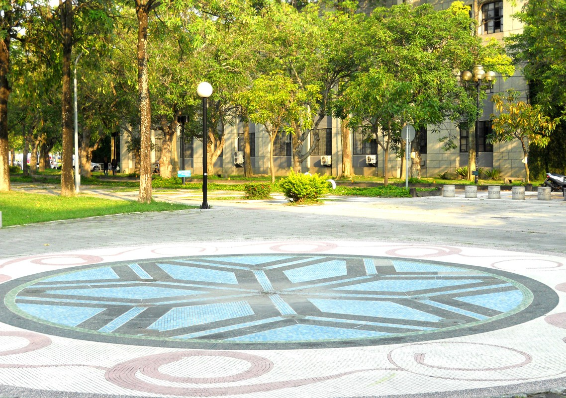
龍潭休憩廣場Longtan Plaza | 龍潭休憩廣場Longtan Plaza

- Time Capsule Area
The 20th anniversary of school was themed with “Make A Wish”, students, faculty, and international friends were invited to write down their dreams on cards and put them into time capsules. These capsules were sealed to commemorate the joyful moment. The prayer text of the principal is “Honestly keeping the new school motto as the foundations, deeply plowing the ethics and humanities of studying atmospheres, cultivating innovative and hardworking students to enter the first-class university”. 2000 cards written by students and faculty in the 20th anniversary of school was buried and predestinated to re-open the buried cards in the 40th anniversary to witness history.
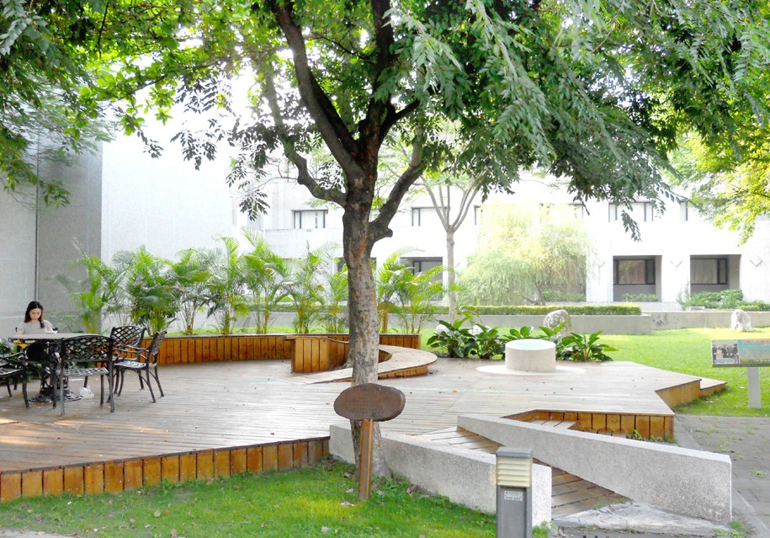 | 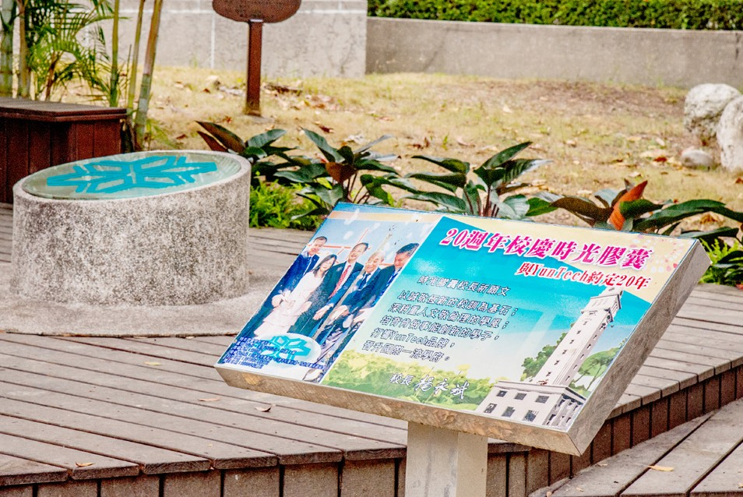
時光膠囊區Time Capsule Area | 時光膠囊區Time Capsule Area

4. Ecologically Friendly Environment

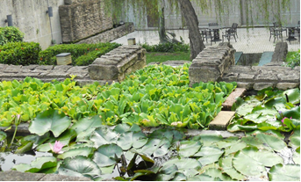 | 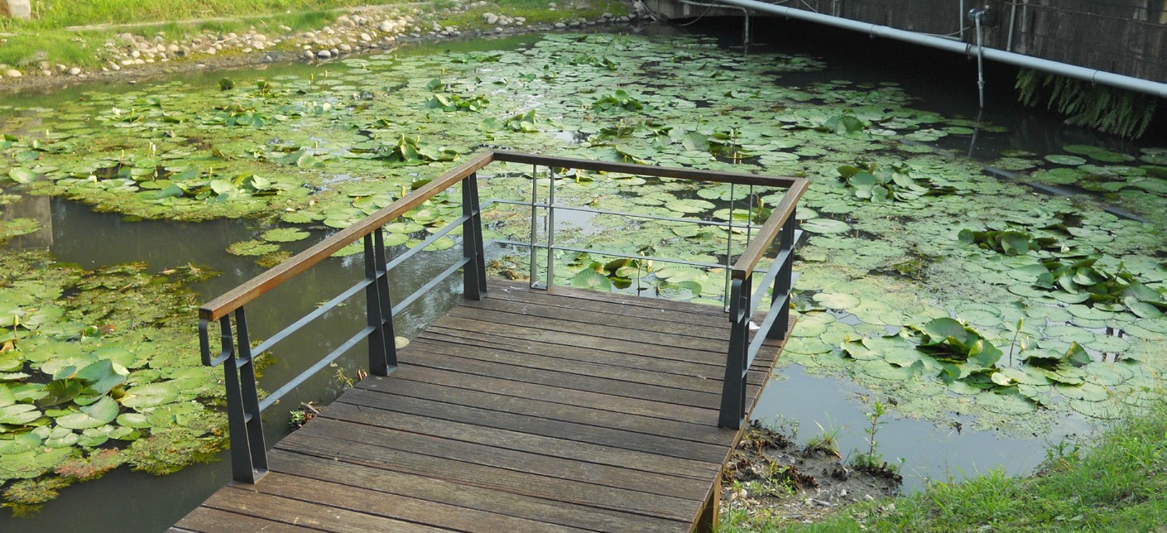
雲科生態園地 - 生態池

There are totally76 species of trees in campus and the amount of trees is more than 6,000. You can see squirrels and various birds anywhere in the campus. Lantana camara blooms along with lake trail. Professional faculty and teachers in both Department of Space Design and Department of Construction planned to flow the purified reclaimed water in the lakes with waterways to restore natural ecology. There are wetlands in the west side of water purification plant in campus. The southern side of the Stadium was subsidized 5.3 million NTDs to construct the ecological pool of Yun Meng Lake to increase the diversity of ecology in campus. The multi-layer ecological green areas in YunTech Cloud Tower: regions close to the forest areas of baseball field. The planned natural ecological forest regions and aquatic creatures in ditches increase students’ understanding about natural ecology.
Characteristic Landscapes: Japanese Flowering Cherry Park, Lotus Pond Park, Prairie area, Lakeside Trail, forest nature trail, Yellow Trumpetbush Trail, Hazel Sterculia Trail and Rotary Park Scenic Trail.

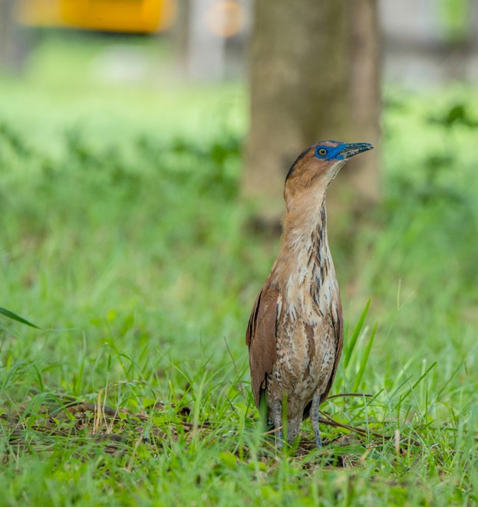 | 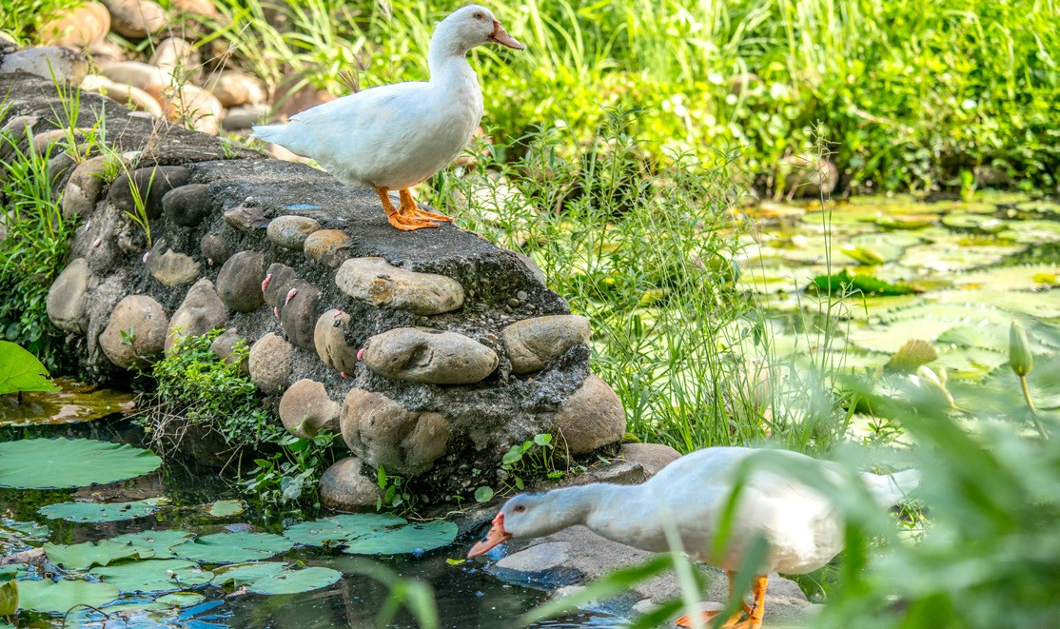
雲科生態園地 - 黑冠麻鷺 | 雲科生態園地 - 鴨子
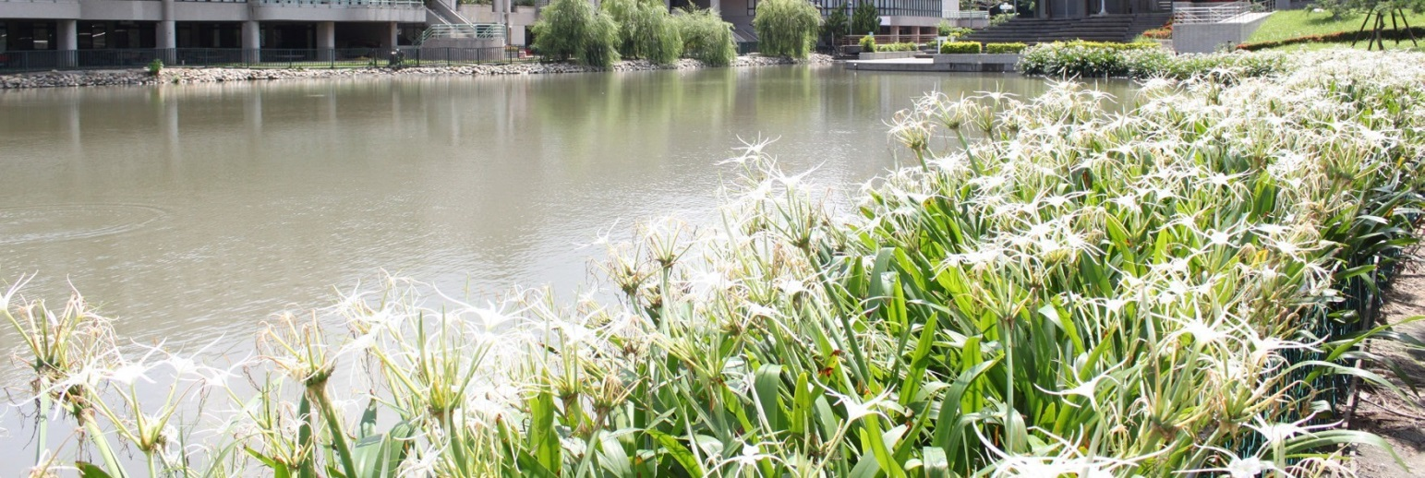
雲夢湖畔 - 蜘蛛百合景觀步道區
5. GreenMetric Word University Rankings

In the operation perspective of campus, comprehensively construct clean and green campus with learning environments of humanities and environmental education. The area of the school place is about 58 hectares. The overall plan for the campus is consummate and there is always blooming flowers and green grass in every season. Our school has won energy-saving awards for many years consecutively and was ranked top 1/4 in the GreenMetric World University Rankings. The school has become well-known as model green campus.

Art Collection

1. Palace of Humanities

The 245 Pings of exhibition spaces in Art Center contain Creation Hall, Exhibition Hall, ZHANG JING Art Hall, CHOU YI-HSIUNG Sculpture Hall, International Art Museum, International Exchange Hall , Collection of Japanese ukiyo-e prints and special exhibition area for the largest compass in Golden World Records are open to people in communities to visit. There are also art collection works decorating the courtyard of Administration Building, which shows the artistic campus with integration of both “humanities arts” and “modern technology”.

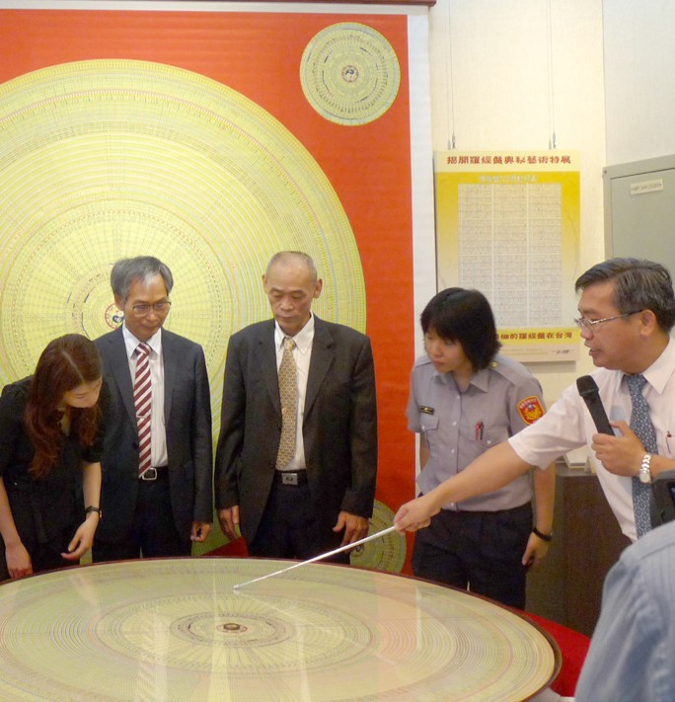
藝術中心典藏「世界最大羅盤」榮獲「金氏世界紀錄」認證
 | 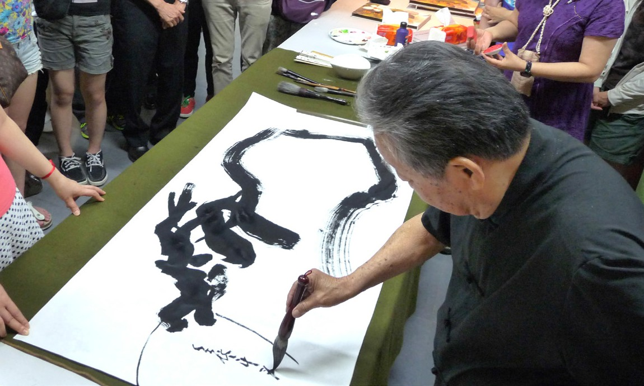
藝術典藏 / 越南漁港 / 油畫 | 駐校藝術家 / 唐永立大師 / 現場揮毫

New Construction

1. Reengineering green hall of schoolhouses

Establishment of sustainable campus with excellent environment and environmental protection ecology is the planned goals of our school. Coordinating with the geographical environments, each construction is required to merge with the natural environment as much as possible. Our campus is excellent, secure, warm, and leisurely with both humanities and science and technology qualities. In the early stage of establishment, our school has already set complete overall planning and principles under the guidance of campus planning committee to fulfill the development needs of school and effectively integrate various resources for the establishment of sustainable mechanisms, which ensures the sustainable campus environment for students and faculty.

Therefore, the promotion of saving water, saving electricity, green power and the establishment of roof-type solar power generation system, new construction of engineering have been all included in the designs of green building, for example, Management Building 3 includes Daily Energy-Saving and Water Resource; Design Building 3 includes Energy-Saving, Water Resource, Indoor Environment and Sewage and Garbage Improvement; Engineering Teaching Building obtained green building badge of Greenery, Rainwater Conservation, Daily Energy-Saving, Water Resource and Sewage and Garbage Improvement. For more funding, our school applied for subsidy to Building Research Institute of Ministry of the Interior and was successfully subsidized 5.3 million NTDs to constructs the ecological pool of Yun Meng Lake and recycling reclaimed water.

YunTech IER Building has already obtained Diamond-Level Green Building Candidate Certificate (includes 9 indexes of Biological Diversity, Greenery, Daily Energy-Saving, Indoor Environment, Water Resource, Sewage and Garbage Improvement, Rainwater Conservation, Waste Reduction and CO₂ Reduction) and the qualification for certificate as candidate of smart building, which makes our campus become green campus with both environmental protection and energy saving concepts. Public construction will be promoted under the guidelines of environmental and ecological protection. Merging in the concepts and approaches of green building, the design ideas for sustainable development could be implemented.

2. Safe and high quality environment

a.Construction of Barrier-free Campus Environment

To implement friendly campus and accessible facilities, our school actively promotes the investigation works about gender spaces in campus. Forum about the gender spaces and accessible spaces were held and representatives of faculty, volunteer counselor teachers, and members from gender equality committee were invited to review the gender and accessible spaces in the campus. In addition to review the improvement situations for the suggestions proposed last academic year, the forum also continued to review the friendly level of campus spaces. Improvements were actively conducted according to the reviews for constructing friendly campus.

b. Provision of Learning Environment

In response to the demands of teaching and school affairs in the campus, new excellent buildings has been built continuously to provide good learning spaces.

Future Perspectives

1. Upgrade to green and smart environmental protection concepts

To continuously elevate the level of campus intelligence and construct sustainable excellent environment complying with the requirement of environmental ecology, Yun Tech has already planned new energy-saving strategies and smart monitoring system in the future to establish campus intelligence and form institutionalized management. Currently, our school actively applied for the “Demonstration Plans for Sustainable Innovation and Implementation of Smart Community” to Ministry of the Interior (Architecture and Building Research Institute) and already obtained subsidy. In the future, our school will integrate the subsidy with self-financing budget and 4 perspectives of energy saving and carbon reduction, safety monitoring, intelligent traffic and health and comfort to comprehensively integrate the functions so as to form smart management and provide a comfortable, energy-saving, convenient and safe environment.

The four perspectives for “Demonstration Plans for Sustainable Innovation and Implementation of Smart Community” that school will apply for in the future includes:

Energy saving and carbon reduction:
Smart load management, smart grid, smart monitoring with renewable energy, intelligence management with sustainable water resources optimal intelligence management for smart energy-saving in power supply in classes and public equipment.

Safety monitoring:
Smart fire warning system, emergency system ,smart campus monitoring, security monitoring for potential flood areas, earthquake monitoring system and information platform showing dormitory information for both students in campus and out of campus

Health and comfort:
Air quality improvement system, real-time monitoring system of PM2.5 and related equipment

Intelligent traffic:
Vehicle access control system, smart immediate displaying system for spaces in parking lots, monitoring system for the immediate traffic dynamics of school buses and garbage trucks, intelligence platform for carpool traffic

a. Energy saving and carbon reduction

Establish “Energy-Saving and Resource Management System” to complete the loading management of electricity uses and water use monitoring so as to effectively save the costs of electricity and the substantial electricity uses. Save water use and decrease leakage of water to lower water fees. After monitoring the electricity and water uses for certain time period and recording the big data, professional analyses on these data could provide references for YunTech to stipulate management policies for saving electricity and water. Through the open database and energy billboards, students and faculty could fully understand the existing situation of energy uses in campus. The management of each energy-saving item (such as policy of uninstallation and switch-off of air conditioning in separate time period and region) discloses the monitoring data of water and electricity uses to let participants know the effectiveness for saving water and electricity, which largely elevates the willingness to follow the policies.

b. Safe monitoring

“Safe Monitoring System” constructs secure campus environment to provide students and faculty with assured spaces for learning and researches. Integrate the existing mechanical and electrical equipment system to broaden the coverage. Improve the remote and potentially dangerous areas by setting warning lights and sounds. Take advantage of IP-cam to elevate the quality of photography and electronic protection functions and deter the potential crimes. This could also reduce the burden of guards in campus. Establishment of environmental safety monitoring system collecting environmental information such as the fire alarm network system, alarm monitoring of floods in low-lying areas in campus, earthquake monitoring can provide immediate information for personnel responsible for environment, health, and safety affairs. This ensures the professional personnel could rapidly control the existing situation and accelerate the procedures for processing hazards. Open information revealed to students and faculty help them to understand the existing situation of campus and make them become part of the campus community.

c. Intelligent transportation
“Intelligent Transportation System” improves the manual management for the access of vehicles in campus via using e-tag to identify the vehicles entering and exiting the campus and strengthen the control and management for vehicle accesses. The induction coils for the accesses of vehicles were designed under the parking lot space planning project. Current vacancy in parking lots will be shown in cooperation with the development of smart parking aid APP of YunTech. Students and faculty can use handheld mobile devices to instantly know where can find empty parking spaces and decrease the time used for finding parking space as well as oil consumption. To elevate the transportation efficiency of school buses, GPS positioning devices were installed on the school buses for students and faculty to use handheld mobile devices to know the routes and reaching time of school buses. This is the development for the APP of car-pool platform for vehicles in life cycle.

d. Health and comfort

The first stage of “Health and Comfort Management System” for the utilization of space quality monitoring provides the immediate data about PM2.5 for air quality in large spaces indoor and spaces outside campus. The air quality indoor will be digitized and immediately showed. Establishment of database provides the references and directions for the improvement of air quality. The second stage is to partition the indoor spaces to undergo improvement (such as using full heat exchanger, fresh air blowers, and etc.) in cooperation with air filter devices to get rid of hazardous materials and lower the concentration of carbon dioxides and improve the relative humidity indoor. This can provide comfortable learning and exercise spaces for students and faculty to increase learning effectiveness.

2. Innovative engineering of smart green buildings

a. To fulfill the demands of each school affair, our school usually needs to closely cooperate with each unit to handle various new constructions. Since it is always stipulated to complete all works in time under the circumstances of limited human resources and time, modern smart information technology should be applied in the progress of engineering to ensure the quality and time scheduling of significant works.

b. The IER Building already applied BIM (Building Information Modeling) to control the building structures and conflicting points of each pipeline in advance. The corresponding solution to the adjustment of pipeline elevation, discharge slope, or etc. was also handled before practices. The related figures could serve as references for the repairs in the future to lower the maintenances costs. In addition, the establishment of CCTV can help to control the construction sites in the construction processes, which allows school to control the construction situation of construction sites immediately and lower the loads of personnel.

c. Through innovative control and management, all the significant works (IER Building) all reached the targets and completed as scheduled.

